



**SM6P07NI Digital Media Project**

**20% Report**

**2024-25 Autumn**

**Student Name: Sarina Jimi**

**London Met ID: 22015940**

**College ID: NP01MM4S220014**

**External Supervisor: Saugat Basnet**

**Internal Supervisor: Parbat Bhujel**

**Assignment Due Date: 7 May 2025**

**Assignment Submission Date: 7 May 2025**

**Word Count: 1467**

|  |  |
| --- | --- |
| **YouTube Link:** | **https://youtu.be/R2qPIqCggQc** |

*I confirm that I understand my coursework needs to be submitted online via Google Classroom under the relevant module page before the deadline in order for my assignment to be accepted and marked. I am fully aware that late submissions will be treated as non-submission and a marks of zero will be awarded.*

**Abstract**

The Digital Media Project(DMP) is an important part of our assignment and carries an overall weight of 20%. The project is a short motion graphic video which will act as advertisement for “Farmshop”. The video will show just how fresh and organic the produce that you get at Farmshop is.

**Contents**

1. Introduction 1

1.1 Topic 1

1.2 Area of Research 1

2. Aims of Project 2

3. Target Audience 3

4. Product Research 4

5. Technologies Employed 6

6. Project Plan 7

7. Production Phases 8

8. Resources 9

9. User Testing & Findings 12

Conclusion 17

References 18

Appendix 20

**Table of Figure:**

Figure 1: Product Review 1 4

Figure 2: Old Gantt Chart 7

Figure 3: New Gantt Chart 7

Figure 4: Script 8

Figure 5: software used 9

Figure 6: Hardware specification 10

Figure 7: Hardware tool 10

Figure 8: One Drive 11

Figure 9: YouTube 11

Figure 10: Google form 11

# 1. Introduction

## Topic

The title of my project is “Farmshop: Connecting Farms to your home”. This title is chosen because the video aims to show just how fresh and organic the produce that you get at Farmshop is. By creating a captivating video that blends 2D animation, motion graphics and text narration smoothly, it will promote the brand as well as their app from which the customers can order fresh produce.

## Area of Research

The main research topic was about visual storytelling and motion graphics. Before concluding what was required, research was done one the software to be used, character design, narrative development and so on. The goal was to use motion graphics to visually show the benefits f Farmshop in an engaging and informative way. This project aimed to discover the tools, techniques and storytelling methods necessary to create an interesting and easy to understand motion graphic video.

# 2. Aims of Project

The primary aim of this project is to create a TVC/motion graphics video, which is both engaging and informative, for Farmshop, a business that delivers fresh produce directly from farms to customers. The video will show the journey of the produce. Additionally, it will highlight the simplicity and convenience of using the Farmshop mobile app to order fresh items.

The purpose of the project is to enhance brand awareness by helping people understand what Farmshop does and how it works. By using a colourful, animated format to show the entire journey, the video will make the concept of fresh , farm-sourced shopping more accessible and appealing to a wide range of viewers.

Once released, the video will accomplish some of the key objectives. It will attract potential customers by showing the transparency and efficiency of the service, it will show that the app is easy to use and that the food is really fresh which will lead to more app downloads. These objectives will be accomplished by the colourful graphics, smooth animations and a clear narrative structure that will simplify the complex process into a visually engaging format.

Furthermore, this project will also show that motion graphics can be used to tell a story and explain things better than just text or photos. It will help Farmshop by serving as a marketing tool to make the brand stand out.

# 3. Target Audience

The project’s target audience is primarily going to be those who are too busy to travel and search for good, organic produce, as well as those who work from home. It is also for people who are health conscious enough to prefer organic produce. This demographic means that the range of people is going to those who are old enough to work and are busy with work.

* Age:

In terms of age, the target audience ranges from people who have just started to work to people who have been in the working field for a very long time. People who are health conscious is also included whether they be teenagers or adults.

* Gender:

In terms of gender, it is a video that is not exclusive to any one gender. Both male, female or any other gender can be influenced by the video.

* Ethinicity and Location

Regarding ethnicity, the project aims to reach individuals from diverse cultural backgrounds but for the location, only people who live in Kathmandu are targeted as it is organic produce which will rot the more distance it has to travel.

# 4. Product Research

During the product research phase, different sources and methods were used to collect helpful information and materials. This helped build better understanding of the topic and how to use motion graphic effectively.

The research process included a detailed look at the Farmshop website to collect official information about its services, policies, and how it operates. Along with that, visits were made to the physical store to observe how things work. This hands-on experience gave useful insights into the real-life functioning of Farmshop and customer behaviour.

Also, different theories, techniques, and practices in and motion graphics were studied to help guide the creative process. This included looking at new media examples and product reviews to understand what works well in educational videos. By using what was learned from this research, the project was able to get a clear idea of the topic and use good storytelling and visual methods to make an interesting and informative motion graphic about how Farmshop works and what it offers.

* **Camera Moves in 2D Animation - How its done (Storm, 2022)**

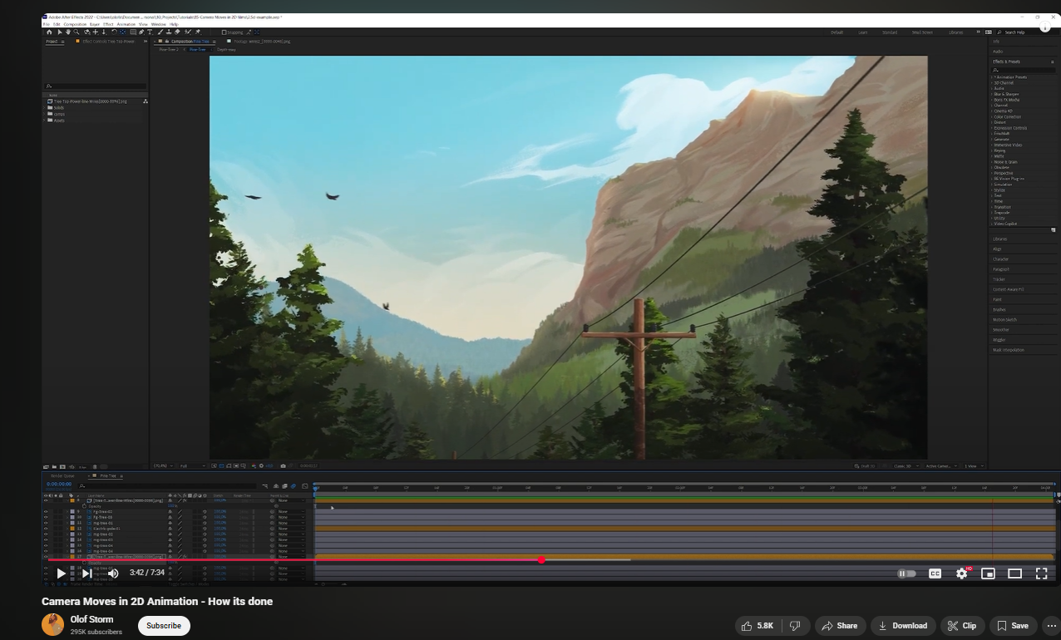

Figure : Product Review 1

In this video, various methods for creating the illusion of camera movement was explained with key techniques like parallax scrolling; using layered backgrounds that move at difference speeds to create a sense of depth, camera panning and zooming; using horizontal and vertical camera movements to guide viewer focus and add cinematic quality, and perspective shifts; altering the viewpoint within a scene to mimic camera rotations or tilts, enhancing the three-dimensional feel.

# 5. Technologies Employed

**Adobe Photoshop**

* Used to edit the resources/images used to make the motion graphic video.

**Adobe Illustrator**

* Used to make the resource/images used to make the motion graphic video.

**Adobe After Effects**

* Used to edit all the scenes for the motion graphic video as well used to add the text narration and the background music.

# 6. Project Plan

It took a bit more time for Motion graphics animation and the post-production evaluation but the narration part took significantly less time.

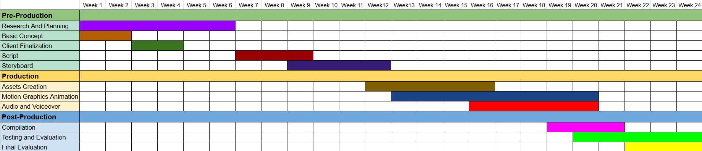

Figure : Old Gantt Chart

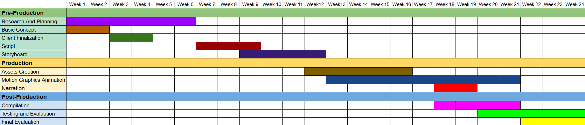

Figure : New Gantt Chart

# 7. Production Phases

* Script

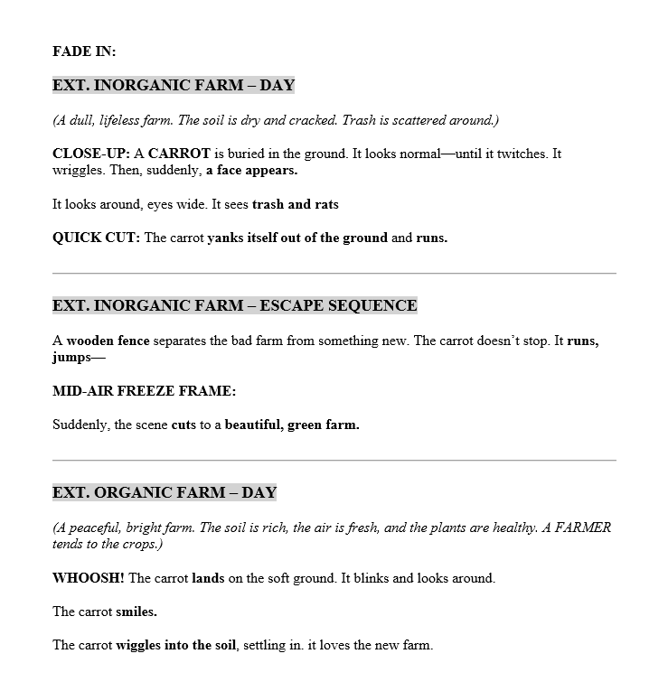

Figure : Script

# 8. Resources

To make the project successful, some important tools were needed. A strong computer with good internet and enough power was necessary to run After Effects smoothly.

● Software Tools

Different software was used for different parts of the project. Adobe Photoshop was used for editing the characters/backgrounds, Adobe Illustrator for making characters and backgrounds, Adobe After Effects for animating and putting everything together, These helped make the animation look clean and interesting

.   

Figure : software used

* Hardware

Laptop Specification:

* Predator Helios 300
* 11th Gen
* 16 GB RAM
* NVIDIA GeForce RTX 3060
* Windows 11

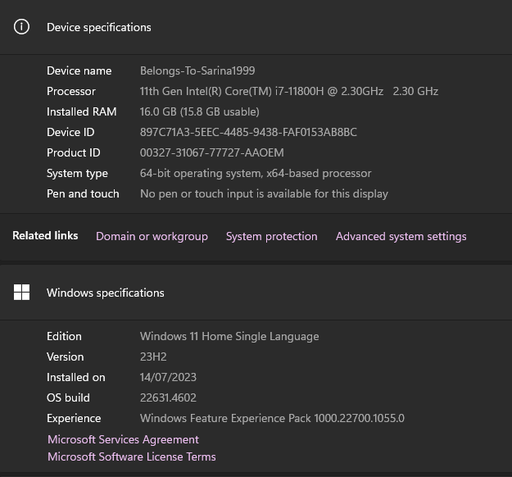

Figure : Hardware specification

Drawing Tablet:

* XP-PEN Deco 01 V2 Graphic Tab

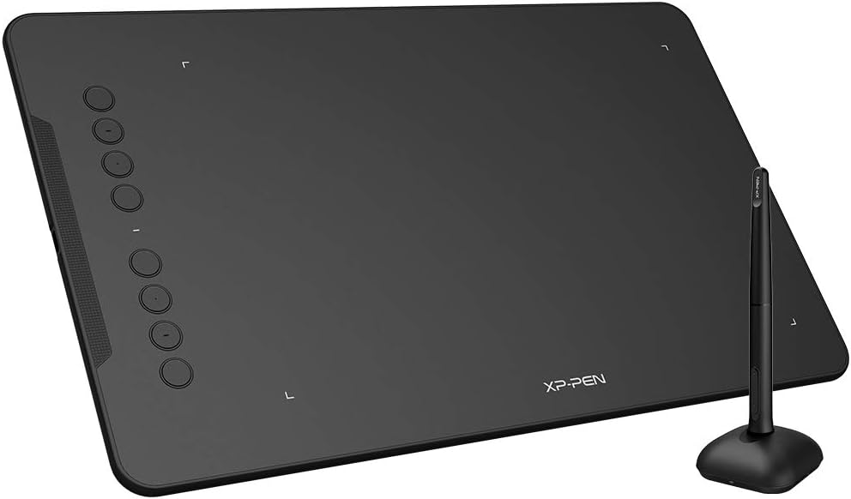

Figure : Hardware tool

* Distribution Platform



Figure : One Drive



Figure : YouTube

* Survey Platform



Figure : Google form

# 9. User Testing & Findings

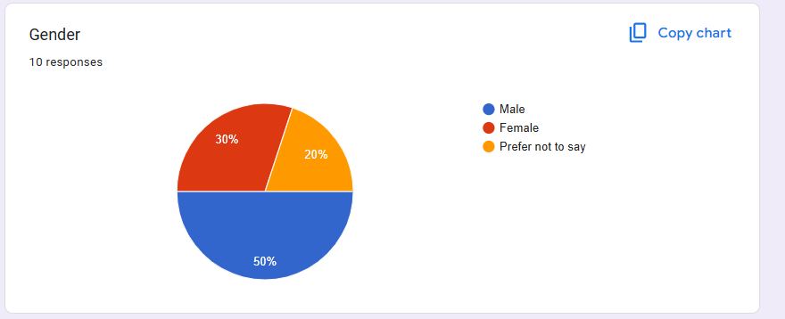

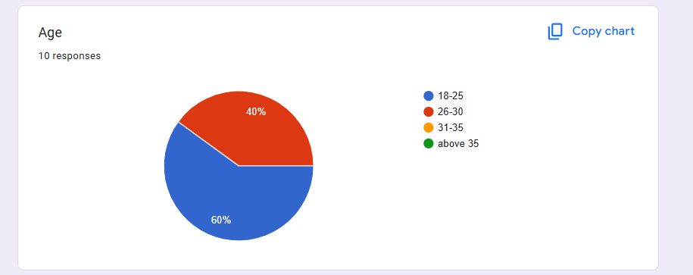

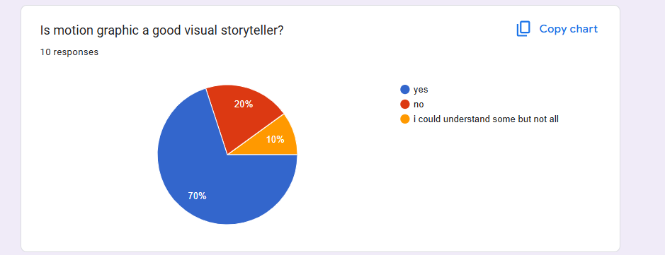

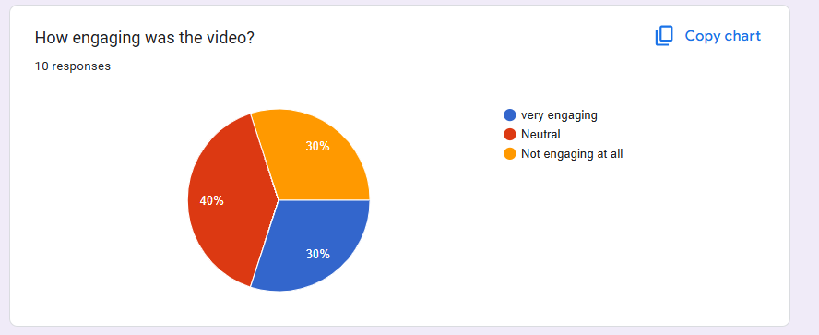

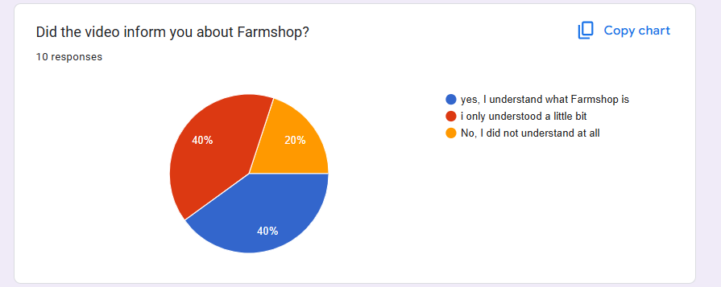

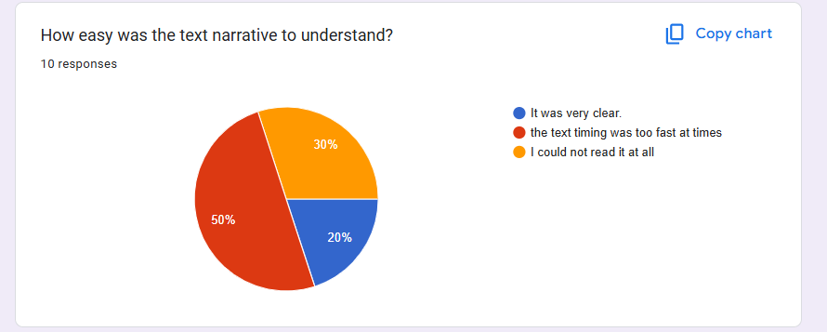

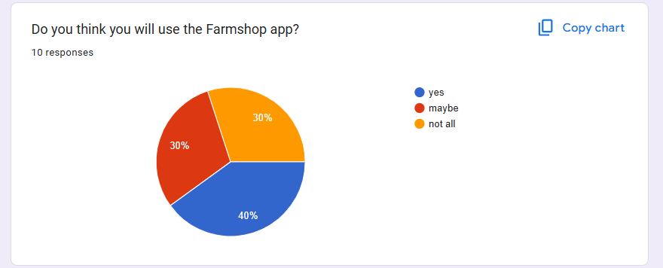

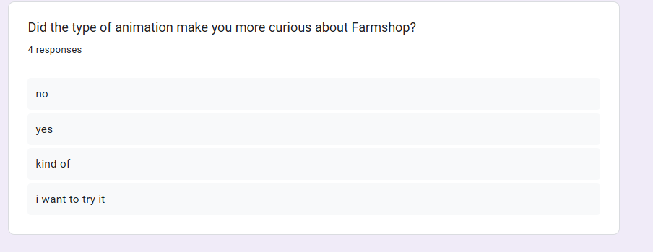

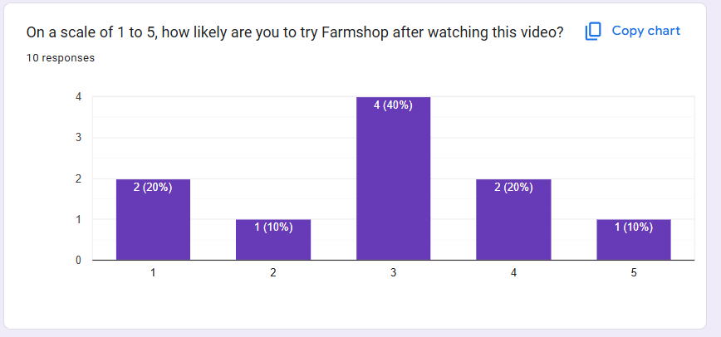

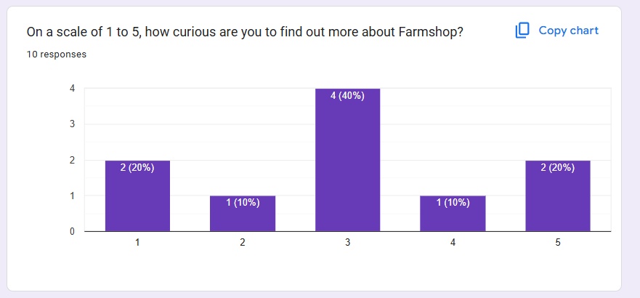

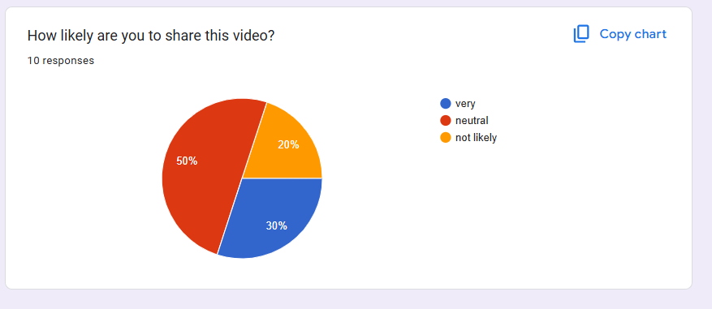

# Conclusion

In conclusion, this project successfully met its goal of creating an engaging and informative motion graphics video about Farmshop. The documentation explained different parts of the project, like the research, production steps, and target audience.

The research phase involved learning about motion graphic techniques and observing how Farmshop works in real life. The production process included writing the script, making a storyboard, animating, and editing. Each step was carefully done to make sure the final video looked good and worked well. Using creative storytelling and bright visuals, the video shows how Farmshop works and why it's useful. This also helps build awareness of the Farmshop brand.

Overall, the project made a short, fun, and helpful video that teaches people about Farmshop and shows how motion graphics can be used to share useful information in an entertaining way.

# References

Storm, O., 2022. *Camera Moves in 2D animation - How its done.* [Online]   
Available at: https://www.youtube.com/watch?v=bMDq0f6VXqI  
[Accessed 23 April 2025].

# Appendix